1. Cluster Beans ( Gavar Fali )

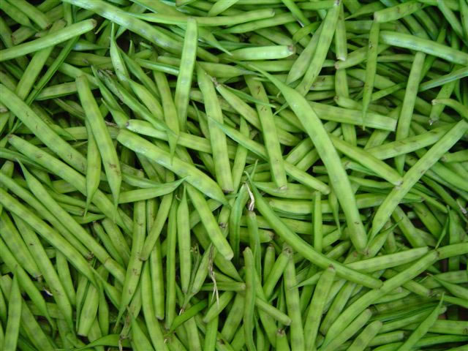

2. Fresh Indian Drumsticks
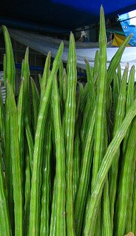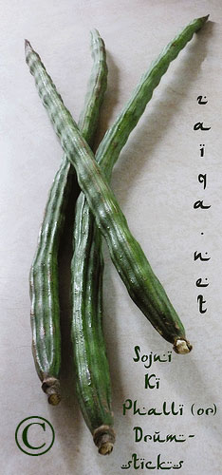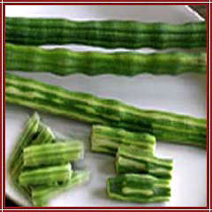

3. Tinda Indian Round Gourd (Citrullus Vulgaris) or also called as Apple Gourd or Indian baby pumpkin; Praecitrullus fistulosus; Cucurbitaceae

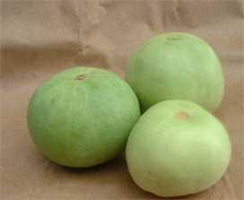

4. Bhindi ( Ladyfinger ) or Okra

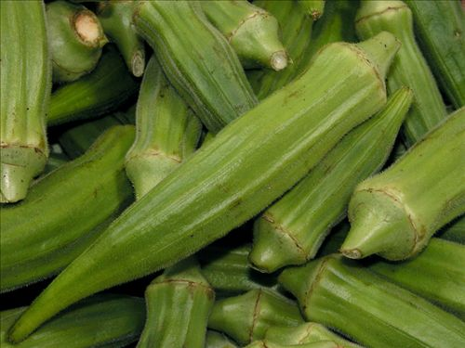

5. Indian Eggplant ( Brinjal ) or Aubergine

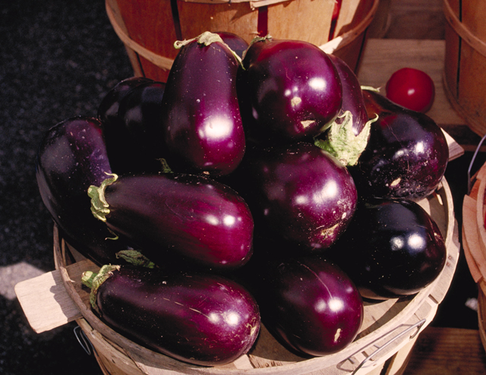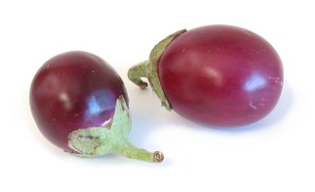

6. Fresh Indian Ivy Gourd ( Tindli )

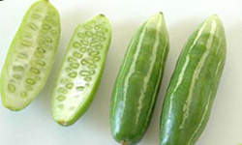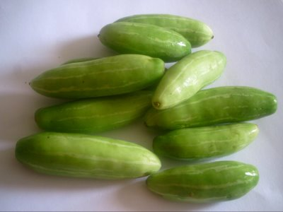

7. Bitter Gourd ( Karela ) or Kaakara Kaaya

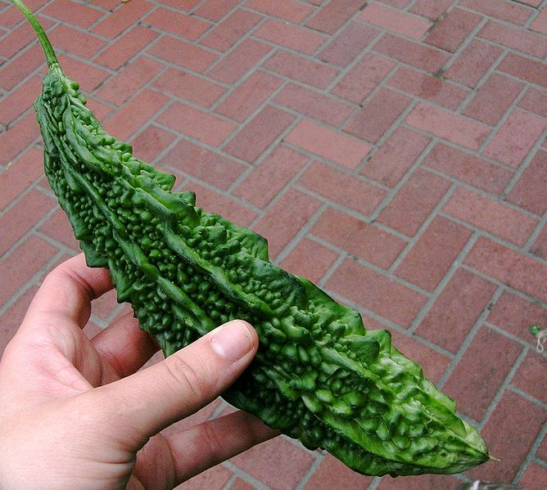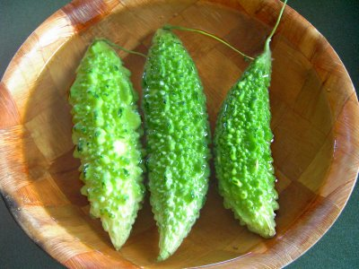

8. Fresh Indian Curry Leaves ( Kari Patta ) or Meetha Neem patta

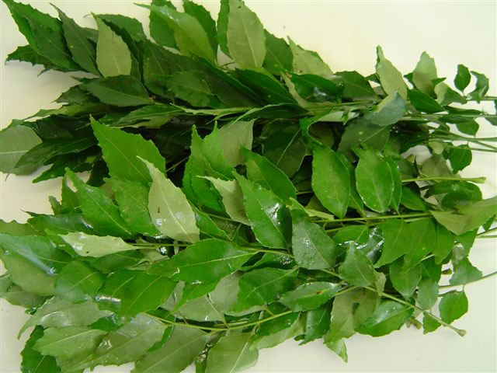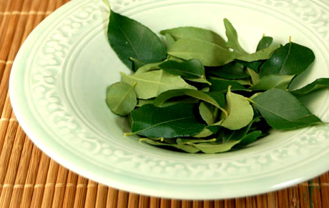
9. Indian Fresh Green chilli

